Lesson 12 - File Upload & AI Cloud Service

1. If you have not completed project setup, please perform project setup following instructions in **C286 L12 Project Setup Guide.docx** first.
2. Complete **Task 1** on **Slide 7** of the Student Notes.
3. Open **Task List** window from the menu **VIEW**, **Task List**. Use the **Filter** function in the Project heading to display only the Task for **Lesson12**.
4. **Activity 1:**
   * + 1. Perform **Tasks 1-1 to 1-3**.
       2. **Tasks 1-1 to 1-2** are in Views/Exercise/Exercise1.cshtml
       3. Verify and compare your code with the lecturers’.

1. **Activity 2:**
   * + 1. Perform **Tasks 2-1 to 2-2**.
       2. **Task 2-2** is in Views/Exercise/Exercise2.cshtml
       3. Verify and compare your code with the lecturers’.
2. Read **Section 4** in student notes.
3. **Activity 3:**
   1. Run the simple voice recorder in Exercise 3, test and make sure that you can record and download a sound file in .wav format.
   2. Run the api/Azure/SpeechtoText/Demo and see speech to text in action. Note, if you face the problem that the subscription key is expired, you can subscribe for your own key at <https://azure.microsoft.com/en-us/try/cognitive-services/?api=speech-services> and update the api key in **AzureApiController.cs**

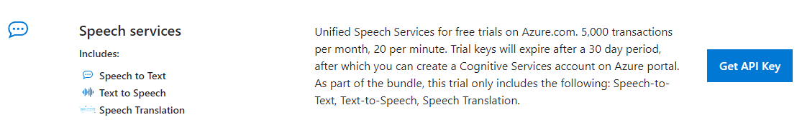

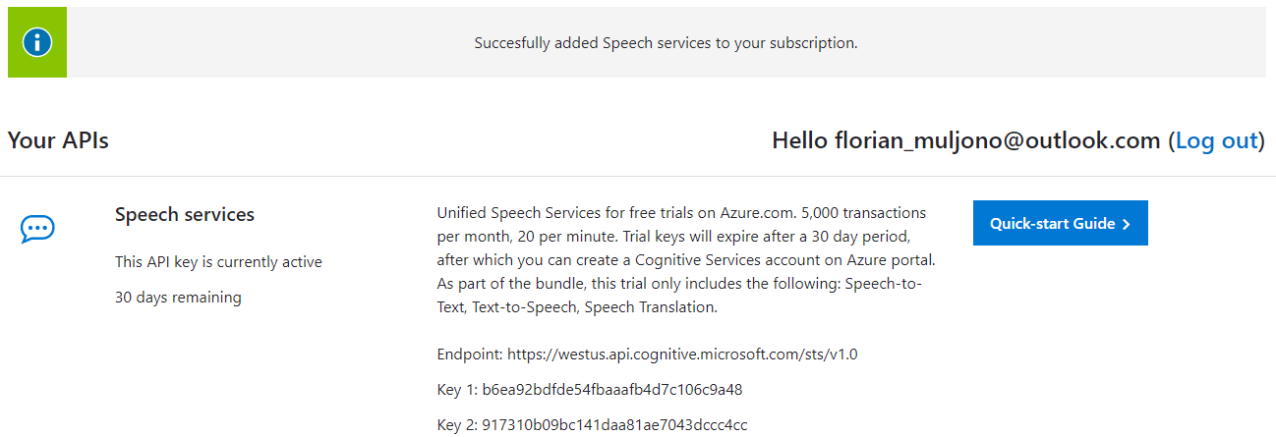

* 1. With reference to [Speech-to-text API reference (REST) - Speech service - Azure Cognitive Services | Microsoft Docs](https://docs.microsoft.com/en-us/azure/cognitive-services/speech-service/rest-speech-to-text), perform **Task 3** and write down your answers below:

|  |  |
| --- | --- |
| Code Fragment | What the code is doing |
| Part 1 | Getting the access token if it is needed |
| Part 2 | Sending the api request on to the web |
| Part 3 | Sends the audio, open request, write and read 1024 raw bytes from the input audio |
| Part 4 | Getting the reply from the web |
| Part 5 | Clones the contents to a physical file |

* 1. Run the sound transcriber (Exercise/Exercise4) and upload the wav file you tested in point a. Wait and see your sound file get transcribed. Note your sound file should not exceed 15 seconds, for practical purposes.

# Solving the Problem

1. You can complete the problem by following the solution tasks in the project. You need to open RPNotes/Index.cshtml to see all solution tasks.
2. Recommended order of implementation:
   1. Add attachments
   2. View and download attachments
   3. Add linkes to simple voice recorder and sound transcriber.

*— End of Worksheet —*